STORED PROCEDURES :

1. The bank needs to process monthly interest for all savings accounts.

**Question:** Write a stored procedure **ProcessMonthlyInterest** that calculates and updates the balance of all savings accounts by applying an interest rate of 1% to the current balance.

CODE :

CREATE TABLE accounts (

account_id NUMBER PRIMARY KEY,

customer_name VARCHAR2(50),

account_type VARCHAR2(20),

balance NUMBER(10,2)

);

INSERT INTO accounts VALUES (1, 'Ram', 'savings', 10000);

INSERT INTO accounts VALUES (2, 'Ravi', 'current', 20000);

INSERT INTO accounts VALUES (3, 'Bhanu', 'savings', 15000);

--INSERT INTO accounts VALUES (4, 'rajesh', 'current', 1000000);

COMMIT;

CREATE OR REPLACE PROCEDURE ProcessMonthlyInterest AS

BEGIN

UPDATE accounts

SET balance = balance + (balance * 0.01)

WHERE account_type = 'savings';

COMMIT;

END;

/

BEGIN

ProcessMonthlyInterest;

END;

/

SELECT * FROM accounts;

OUTPUT :

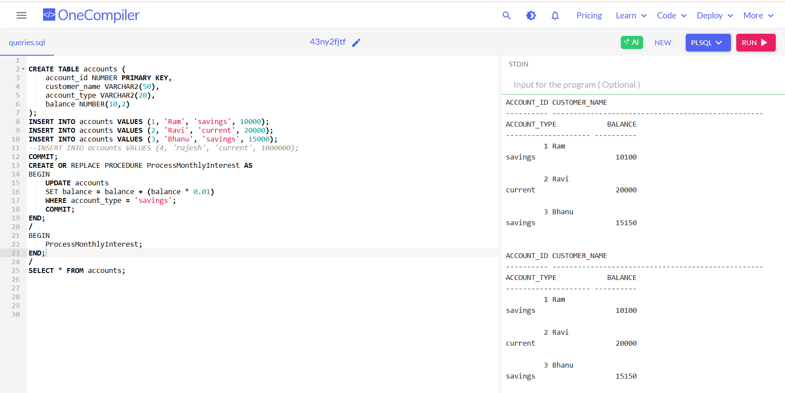

2. The bank wants to implement a bonus scheme for employees based on their performance.

* + **Question:** Write a stored procedure **UpdateEmployeeBonus** that updates the salary of employees in a given department by adding a bonus percentage passed as a parameter.

CODE :

-- employees table

CREATE TABLE employees (

emp_id NUMBER PRIMARY KEY,

name VARCHAR2(50),

department VARCHAR2(30),

salary NUMBER(10,2)

);

--sample data

INSERT INTO employees VALUES (1, 'Ram', 'HR', 50000);

INSERT INTO employees VALUES (2, 'Ravi', 'Finance', 60000);

INSERT INTO employees VALUES (3, 'Bhanu', 'HR', 55000);

INSERT INTO employees VALUES (4, 'Sita', 'Finance', 58000);

INSERT INTO employees VALUES (5, 'Geeta', 'IT', 70000);

COMMIT;

CREATE OR REPLACE PROCEDURE UpdateEmployeeBonus (

dept_name IN VARCHAR2,

bonus_percent IN NUMBER

) AS

BEGIN

UPDATE employees

SET salary = salary + (salary * bonus_percent / 100)

WHERE department = dept_name;

COMMIT;

END;

/

BEGIN

UpdateEmployeeBonus('HR', 10);

END;

/

SELECT * FROM employees;

OUTPUT :

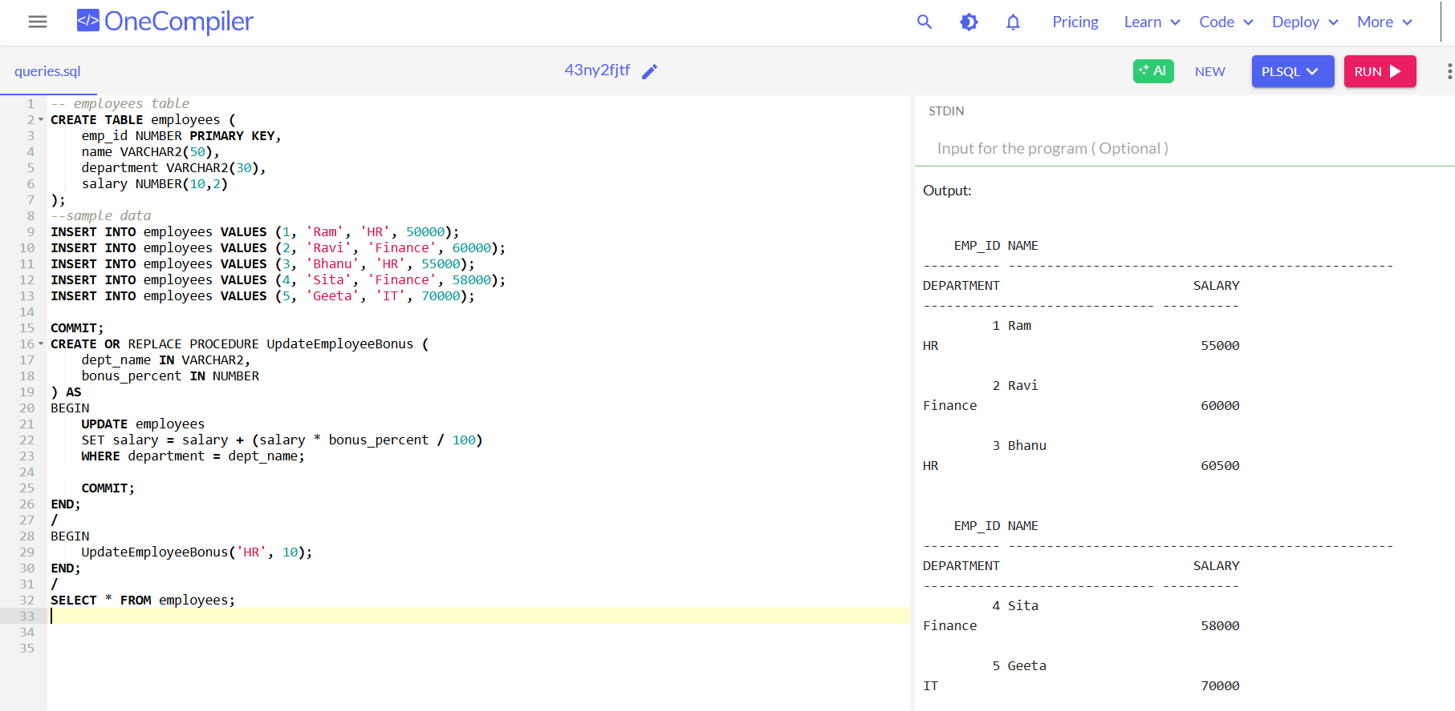

3. Customers should be able to transfer funds between their accounts.

**Question:** Write a stored procedure **TransferFunds** that transfers a specified amount from one account to another, checking that the source account has sufficient balance before making the transfer

CODE :

-- employees table

CREATE TABLE employees (

emp_id NUMBER PRIMARY KEY,

name VARCHAR2(50),

department VARCHAR2(30),

salary NUMBER(10,2)

);

--sample data

INSERT INTO employees VALUES (1, 'Ram', 'HR', 50000);

INSERT INTO employees VALUES (2, 'Ravi', 'Finance', 60000);

INSERT INTO employees VALUES (3, 'Bhanu', 'HR', 55000);

INSERT INTO employees VALUES (4, 'Sita', 'Finance', 58000);

INSERT INTO employees VALUES (5, 'Geeta', 'IT', 70000);

COMMIT;

CREATE OR REPLACE PROCEDURE UpdateEmployeeBonus (

dept_name IN VARCHAR2,

bonus_percent IN NUMBER

) AS

BEGIN

UPDATE employees

SET salary = salary + (salary * bonus_percent / 100)

WHERE department = dept_name;

COMMIT;

END;

/

BEGIN

UpdateEmployeeBonus('HR', 10);

END;

/

SELECT * FROM employees;

OUTPUT :

